Business Requirement Document (BRD)

**Title**: Display “Net Amount” Field in Invoice Header

**Module**: Vendor Invoices – Media and Production

**Prepared By**: Asim Jamil

**Date**: June 18, 2025

# 1. Background / Current Behavior

In ApWorks, the Invoice Header currently displays only the Total Amount, which includes both the base invoice value and tax (i.e., Net + Tax). However, users are not able to directly view the Net Amount (pre-tax total) unless they manually calculate it by subtracting the tax from the total or summing the line-level amounts.  
  
This becomes inefficient and error-prone when reviewing or validating invoices, especially for complex or multi-line invoices.

# 2. Problem Statement

- Lack of a dedicated Net Amount field at the header level forces users to perform manual calculations.  
- This results in inefficiency, particularly when users are validating invoice values, preparing reports, or cross-checking against PO or system-generated totals.  
- In high-volume environments, this manual effort adds unnecessary overhead and increases the chance of errors.

# 3. Objective

Introduce a read-only "Net Amount" field in the invoice header for Media and Production modules, which:  
- Automatically sums all line-level Net Amounts   
- Provides immediate visibility to the base amount of the invoice without requiring manual computation.

# 4. Proposed Solution

## 4.1 UI Changes

- New Field: Net Amount  
- Display Location: In the Invoice Header section alongside Tax Amount and Total Amount(review the mockup below)  
- Field Behavior: Read-only, dynamically populated.  
- Formatting: Same as Total and Tax fields.

## 4.2 Functional Logic

Net Amount = Sum of line-level net amounts  
The system will calculate the net amount by summing all net values from the detail lines, not by subtracting tax from total.

Applicable Modules:  
- Media Invoices  
- Production Invoices

- Broadcast for both pdf and EDI invoices

- Model/Vendor Mapping Previuw

## 4.3 Database

No persistence required unless there is a future requirement. The field can be computed at runtime on invoice load.  
  
  
**4.4 Mockup / UI Changes**

**Invoice UI**

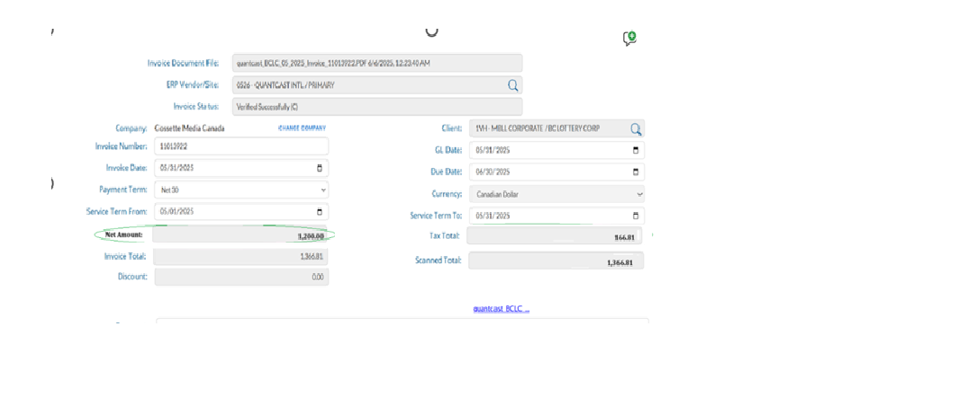

Vendor Mapping:

### **Vendor Mapping UI Enhancements for Net Amount Handling**

To support better clarity around invoice amounts when tax is applicable, the following enhancements will be introduced on the **Vendor Mapping UI**:

#### **Current Behavior**

* The UI currently includes a single field labeled **"Invoice Amount"**, which represents the total amount of the invoice.
* This field continues to function as-is when no tax is applied to the invoice.

#### **New Behavior Based on Tax Selection**

1. **When "No Tax" is selected:**
   1. No changes will be made to the UI or system behavior.
   2. The field **"Invoice Amount"** will remain as it is, reflecting the full invoice value.
2. **When "Invoice has Tax" is selected:**
   1. The label of the existing **"Invoice Amount"** field will be renamed to **"Net Amount"** to more accurately represent the pre-tax value.
   2. A new **read-only field** will be displayed beneath the tax information line, labeled **"Invoice Amount"**.
   3. This field will automatically populate with the sum of the **Net Amount** and **Tax Amount. Value** in this field will be updated based on any change in Net Amount or Tax amount.

#### **Important Note**

* This enhancement is purely **visual** and intended to provide better transparency for users regarding how invoice totals are derived.
* **There will be no functional impact** on the vendor mapping process or downstream calculations.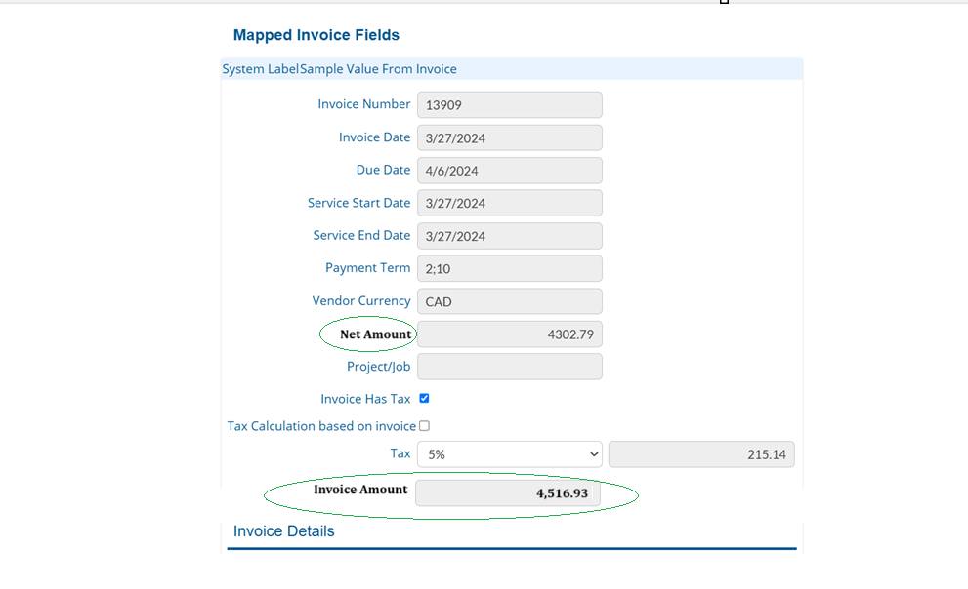

## 4.5 Audit Trail / History

No audit trail or edit tracking required since the field is derived and not editable.

# 5. Non-Functional Requirements

- Calculation must happen instantly upon invoice load or when line items are modified.  
- Consistency with other financial fields in format, alignment, and localization.

# 7. Other Areas

- Option to include Net Amount in:  
 - Invoice export formats (Excel/PDF)  
 - Reporting tools (if needed)

# 8. Examples

Example 1:  
 - Line 1: Net = 1,000 | Tax = 100  
 - Line 2: Net = 500 | Tax = 50  
 - Header View:  
 - Net Amount = 1,500  
 - Tax Amount = 150  
 - Total Amount = 1,650

Example 2:  
 - Single Line: Net = 3,000 | Tax = 300  
 - Header View:  
 - Net Amount = 3,000  
 - Tax Amount = 300  
 - Total Amount = 3,300

# 9. Open Questions:

1) What should be the label of the field (Net Vs Gross)?

[Asim Jamil] Net as described in Image above

2) Where do we need to display the field other than invoice UI screen?

[Asim Jamil] invoice management and reports. The following should be the order of fields on these UI.  
  
Net Amount, Tax, Total Invoice Amount